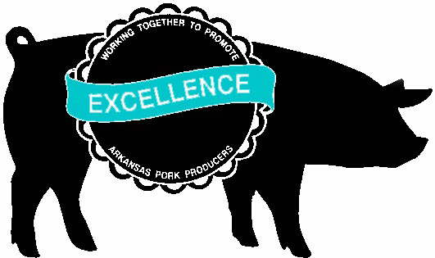
Arkansas Pork Producers Association
JERRY MASTERS 579 Buck Mtn. Road Office: (479) 331-4062
Executive Vice President Dover, AR 72837 Fax: (479) 331-0185
www.arpork.org Email: arkpork@yahoo.com Jerry Cell: (479) 970-0031

September 19, 2019

ADPC & E Commissioners
c/o Jake Harper
Department of Energy and Environment
5301 Northshore Drive
North Little Rock, AR 72118

Dear Commissioners:

We want to thank you for the opportunity to comment on the proposed Third Party Rulemaking to change Regulations 5 and 6 entitled Liquid Animal Waste Systems and Regulations for State Administration of the National Pollution Discharge Elimination System, respectively.

We are opposed to any changes made in these regulations for the following reasons:

It is obvious that the reason this Third Party Rulemaking is a result of the issuance of the first CAFO permit issued in the State of Arkansas. The Commission should base its decision on science. Not fear (FEAR – False Evidence Appearing Real) and emotion or the fact that some opponents just do not like family pork production units and the idea of family operated swine farms located in the Buffalo River Watershed. Family pork production farms have been located in the Buffalo River Watershed for decades without this type of outcry from the environmental activists’ groups.

To make the changes in the Third Party Rulemaking sets a very negative precedent and is not based on science. This sets up a very slippery slope that could eventually affect all ERW watersheds in Arkansas. We realize this Third Party Rulemaking only applies to the Buffalo River Watershed, Medium and Large Swine CAFO’s, but what is next on the opposition’s agenda against agriculture production?

This is a terrible precedent for the Commission to make especially when they have zero scientific basis to make it on. The Commission needs to deny the Third Party Rulemaking on Regulation 5 and Regulation 6.

The proponents of this Third Party Rulemaking go on and on about the threat of the waste handling storage lagoons leaking and the catastrophic failure. In Arkansas’s long history of swine production, we have NEVER had a catastrophic failure. The mid 1990’s studies done of hog farms in the Buffalo River watershed showed that these lagoons had minimal to no impact on groundwater. Not because of the formation underlying them as some have claimed, but because they did not leak. These farms were constructed in the 1970’s. Today’s farms are constructed using much more stringent engineering design standards.

A blanket application of this Third Party Rulemaking to the entire Buffalo River Watershed would be completely contrary to the science generated in the studies conducted on hog farms located in the Buffalo River Watershed in the late 1990’s. Those farms were located in the Buffalo River Watershed in areas underlain by Karst formations and had minimal or no impact on surface and ground water when using the proper best management practices.

An outright change to Reg. 5 and Reg. 6 based on “potential” or “threat” is not a scientific approach.

This Third Party Rulemaking is based on the “precautionary principle” and not objective sound science. The requirements in the CAFO regulation and permitting process have undergone intense scientific scrutiny and have been heavily litigated over the past decade. The Regulation 5 permit is an individual no-discharge permit and has been in place since 1992. It provides plenty of opportunity for public review and scrutiny. This process has served Arkansas well and we would like to encourage the Commission to make no changes to Regulation #5 and Regulation #6.

The Third Party Rulemaking of Regulation 5 and Regulation 6 is an infringement to farmer’s right to farm and private property rights. American Agriculture is the backbone of our economy and our country. Our state’s pork producers have an excellent environmental record. They have proven to be responsible environmental stewards and have always been pro-active in working with ADEQ and its commissioners in meeting the challenges that have faced them.

The Arkansas Pork Producers Association and its membership would like to request that absolutely no decision on this Third Party Rulemaking be made until the Big Creek Research and Extension Team (BCRET) has been given the opportunity to publish its final report. The result of this final report should be the basis of whether there needs to be a permanent moratorium on Medium and Large CAFO’s in the Buffalo River Watershed. The decision needs to be based on Sound Science not on emotional outcries. BCRET was established for the purpose of monitoring and checking for any degradation of the Buffalo River and funded and supported initially by Governor Beebe and continued to be funded and supported under Governor Hutchison.

We would like to thank you for allowing us to comment on these proposed changes. One again, WE would like to ask the ADPC and E Commissioners to make their decision on sound scientific facts not on emotion and sound bites and deny any changes to Regulation 5 and Regulation 6.

Sincerely,

Jerry Masters
Executive Vice- President
Arkansas Pork Producers Association
579 Buck Mountain Road
Dover, AR 72837

